Download this document and add print screens to show what you did to provide a solution. Answer the questions below.

Problem:

The R&D team needs to more effectively collaborate. They need a team site in the CS Portal that will allow members to easily share information and collaborate. All and only the R&D team members should be able to view the R&D site and add content. Two team members will need to design sites and subsites for the team. All team members will need to view the Main Portal site. They cannot contribute. All team members are in the R&D AD group.

Members that can contribute to R&D site

· ssneed

· mzinn

· bglen

Design members for R&D site

· scartie

· tjones

1. List users and groups you may have created in Active directory

|  |
| --- |
| Users: ssneed, mzinn, bglen, scaetie, tjones, LazyBoy  Groups: R&DAll, R&Design, R&DMembers |

1. List members of the AD groups (if create additional groups)

|  |
| --- |
| R&Dall: ssneed, mzinn, bglen, scaetie, tjones, LazyBoy  R&Design: scaetie, tjones  R&Dmembers: ssneed, mzinn, bglen |

1. List sharepoint groups to create( if you create sharepoint groups)**Remember only create additional groups if the default groups won’t work for your solution.

|  |
| --- |
| n/a |

1. Describe what you did to provide a solution to the above problem

|  |
| --- |
| 1. Added the AD users and groups 2. Login as the Admin 3. Created the R&D SubSite 4. Went back to the cs portal home page 5. Added R&Dall group to be a member of visitors to have read permissions 6. Went back to the R&D subsite page to change its permissions 7. Stopped inheriting 8. Added the R&Dmembers to r&d member group, and R&Design to design group. 9. Test LazyBoy, ssneed, and scartie (don’t have to test each group member since they all share the same group) |

1. Test your solution

The LazyBoy Account can view, but not add content to the team site

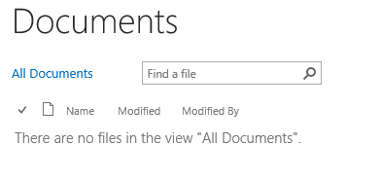

The ssneed account could view the main cs portal page, but allowed to edit the R&D portal page contents

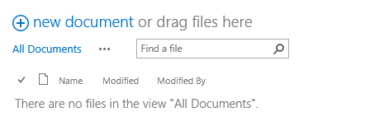

The scartie account could view the main cs portail page, but allowed more option with the design changes to the R&D portal. Allowed adding a link list.

